Software Documentation:

ETA Shuttle Project

**Mohammed Kassem (Team Leader)**

**Syed Hyder**

**Kyle Andrews**

**Matthew Jackovich**

**Table of Contents**

Table of Contents………………………………………………………………….1

1. Development Plan………………………………………………………….....2
   1. Project Overview……………………………………………………...2
   2. Project purpose, scope, objectives………………………………….....2
   3. Team organization…………………………………………………….3
   4. Problem resolution policies…………………………………………...4
   5. Project Plan…………………………………………………………...5
   6. Configuration Management Plan……………………………………..6
   7. Technologies…………………………………………………………..8
2. Requirements Specification…………………………………………………...8
   1. Problem Description…………………………………………………..8
   2. Users/Perspectives…………………………………………………….9
   3. Functional Requirements……………………………………………...9
   4. Non-Functional Requirements………………………………………..10
   5. Business Constraints………………………………………………….10
   6. Technical Constraints…………………………………………………11
   7. Requirements Traceability Matrix…………………………………….12
3. Design Specification…………………………………………………………..13
   1. Domain Analysis………………………………………………………13
   2. System Context………………………………………………………..14
   3. Architecture Design……………………………………………………15
   4. System Design…………………………………………………………16
   5. Other Issues…………………………………………………………….17
4. Testing Plan…………………………………………………………………….17
   1. Approach for testing……………………………………………………17
   2. Functional Testing……………………………………………………...17
   3. Non-Functional Testing………………………………………………...18
   4. Integration Testing……………………………………………………...19
   5. System Design………………………………………………………….19
   6. User Acceptance Testing……………………………………………….19
   7. Schedule………………………………………………………………...20
5. Development Plan
   1. *Project Overview*

Wayne State University provides free of charge shuttle transportation services for students and faculty. There are two different shuttles that cycle Wayne State’s campus to help make transportation convenient over long distances. The main campus shuttle is available Monday thru Friday from 7 a.m. thru 6 p.m. and runs a full cycle around campus at 15 minute intervals. The medical campus shuttle is available Monday thru Friday from 7 a.m. thru 9 p.m. and runs from the main campus to the medical campus at 30 minute intervals. Wayne State University provides students and faculty with transportation, covering miles of distance from one stop to another. The map located on [www.maps.wayne.edu](http://www.maps.wayne.edu) shows the stops of the shuttle and the real time location of the bus (updated every three seconds). However, the map presented by Wayne State does not conveniently present data to the end user (students and faculty) which includes the ETA (estimated time of arrival) of the shuttle to each particular stop.

* 1. *Project Purpose, Scope, Objectives*

The current shuttle service system provided by Wayne State University consists of a mobile website allowing students and faculty to view a map of the main and medical campus, route and stops of the shuttle, and a visual representation of the shuttle. However, there are limitations to the current system. The current system does not calculate the estimated arrival time (ETA) of the shuttle for a particular stop. The website does not show the ETA of all the stops based on the current location of the shuttle according to the speed of the shuttle. As a result, the objective of this project is to incorporate the ETA feature into the current system to better inform shuttle users on an estimated arrival time of the shuttle for the stops. The purpose of incorporating an ETA feature is to help students and faculty manage their time effectively and productively. By displaying the ETA of the shuttle for a particular stop, students and faculty will not wait for long periods of time for the shuttle to arrive.

* 1. *Team Organization*

Our team consists of four students and each member of the group is assigned tasks every week that correlate with technical and non-technical skills. Tasks are assigned by Mohammed (the team leader) every three days according to a member’s prior knowledge and conformability executing a particular task. Tasks are divided into technical and non-technical roles. The technical roles consisted of front-end developers, back-end developers, and document writers. The non-technical roles consisted of team lead, contact person of the team, team planner, and back-up team lead/assistant lead. Mohammed Kassem and Mathew Jackovich are the front-end developers while Kyle Andrews is the back-end developer and Syed Hyder is the document writer and occasional front-end developer. The team is assigned with a lead that makes sure that all tasks are done properly and monitors the progression of the project. Mohammad Kassem was chosen as the team lead by the team based on his leadership skills, management skills, his personal desire of being the team lead, and due to the fact that he was willing to be available to talk and communicate with the members of the group and the project clients and staff at any time. Kyle Andrews was chosen as the assistant lead/back-up lead by the team based on his past experiences as lead at work and school. The team planner is responsible for laying out the execution plan, duties, solutions to problems, and analyzing the progression of the team based on the feedbacks and team meetings by taking notes. Syed Hyder was chosen as the team planner by the team based on his writing skills, planning and analysis skills, and problem-solving skills. The contact person of the team is responsible for contacting the project clients and staff/faculty in involved in the project through emails and phone calls, setting up meetings, and representing the team in meetings. Mathew Jackovich was chosen for this role based on his communication and interpersonal skills.

* 1. *Problem Resolution Policies*

The team holds weekly meetings through teamviewer and in-person meetings at least once every week. During the meeting, each member gives a feedback on member’s weekly performance and gives any additional advice or suggestion. If a problem arises, each member shares ideas and opinions on how to tackle the problem and figure out solutions. If there is a difference in opinion between the members of the group, the majority rule will come into effect. Thus, the idea or strategy that majority of the group members agree upon will be used to solve a problem or dispute within the group. If there is no majority opinion on a certain matter, then the team lead will have the power to decide on the matter and will have the final say. Additionally, each team member has a personal one-on-one meeting with the team lead to share any concerns and questions regarding the project or other group members and is assigned weekly tasks. The team lead is responsible for any organizational changes or team changes if the team lead deems it necessary after hearing from all the members of the group.

* 1. *Project Plan*

The project plan is to build a software system on the World Wide Web that contains the map of the Wayne State University campus, the route of the shuttle, the image of the shuttle as a marker on the route in real-time, the stops of the shuttle indicated as a circle on the route, and the ETA of each stop based on the current location and speed of the shuttle. The system will have the user click on each stop and a small window will pop-up on the same page synchronously that will display the information of the stop, such as the name of the building the stop is by, and it will display the ETA. Once we build the software system for online computer users, the team will start building the software for an Android device. The project plan is to be executed in a step-by-step process where the progression of the plan is based on doing the basics first. Following is the table that highlights the tasks of the project plan in a procedural manner:

|  |  |
| --- | --- |
| Task No. | Task |
| 1 | Launch of the website: www.wsushuttle.com |
| 2 | Adding map of the Campus on the website |
| 3 | Adding route on the map |
| 4 | Adding stops on the map |
| 5 | Adding ETA feature on the map |
| 6 | Building Mobile Application |
| 7 | Final Overview/Testing |

* 1. *Configuration Management Plan*

System Conception

Requirements Analysis

Design

Development

Test

Acceptance Test

Overview and Maintenance

* 1. *Technologies*

The software system will be built on the Windows Operating System and would require an internet connection to access the website. The mobile application will be built for an android device. The programming language for the front-end system will be a combination of PHP and JavaScript and for the back-end system it will be MQSQL. The programming language that will be used for the mobile application is Java.

1. Requirements Specification
   1. *Problem Description*

The current system of the Wayne State University shuttle service contains problems and issues that limit the facility of the shuttle to the students and faculty. One problem with the current system is best accessible on a computer due to the fact that it serves multiple purposes, not just the shuttle route. Most people have mobile devices these days and are always on the go and may not have access to a computer or have time to find a computer and go to the website to look at the shuttle map. It would be convenient to have a website and mobile application that focuses on the shuttle bus alone. Another major problem with the current system is that it does not show the Estimated Arrival Time of the shuttle for each stop. The issue with that is, users don’t know exactly what time to show up on the stop or they are not informed of any delay that may have caused due to traffic or bad road conditions which may result in the late arrival of the shuttle for a particular stop. This causes the user of the shuttle to wait for the shuttle for long periods of time which not only is exhausting but also time consuming and inefficient. There needs to be an added feature to the current system which can allow the users to view the Estimated Time Arrival of the shuttle for each stop.

* 1. *Users/ Perspectives*

The software system that we are building is being built from the perspective that the users of our system will be mostly the students and faculty/staff of the Wayne State University that use the shuttle as a means for transportation around the campus. We are assuming that the user is a bit familiar with the geographical location of various stops on the campus. The system will be public and will be accessible to any person who has access to a computer with an internet connection or has the mobile application on the android device.

* 1. *Functional Requirements*

The software system that we are making for the online website requires the user to go to the website [www.wsushuttle.com](http://www.wsushuttle.com) to view the map of the campus, the route of the shuttle and the stops of the shuttle, and to use ETA feature on the website. The user would be required to click the circles on the route which are visual representation of the stops in order to view the ETA for the stops. Once the user clicks on a particular stop, a smaller window will pop up synchronously which will display the ETA of the stop.

* 1. *Non-Functional Requirements*

In order to use the software system, the user must be connected to an internet connection on a computer or mobile device. If the user does not have access to an internet connection, then he/she must have an android device to install the mobile application and have access to that application. Once the user has access to the software system, he/she must be aware of the hours and days of operation of the shuttle. The visual representation of the shuttle will not be seen on the map during non-operational hours and the system will not provide the ETA since there would be no shuttle running during non-operational hours. The user must be aware of the geographical location of the stop by looking at the map, be sure where to stop by exactly at the stop in order to be on the shuttle, know how to get to the desired location after the shuttle drops off the user at a nearby stop, and be knowledgeable of the areas and locations of the campus and the surroundings.

* 1. *Business Constraints*

The main business constraints we have had to work with are Wayne State’s security policies. We are not able to modify the current working website, thus we needed to build our own from scratch. We were given only the bus and route coordinates and had to build up from there.

* 1. *Technical Constraints*

The coordinate points of the latitude and longitude for the route and stops that are given to us by the Wayne State University IT department are not perfectly exact. The coordinate points will need an offset algorithm that may fix the issue for the exact coordinates. Furthermore, we were informed by the IT department of Wayne State University that the visual representation of the shuttle on the map and the actual location of the shuttle are off by about thirty seconds. There is nothing that could be done to fix that.

* 1. *Requirements Traceability Matrix*

|  |  |
| --- | --- |
| Test No. | Test Objective/ Test Scenarios |
| 1 | Validate that the website is working and is open to the public. |
| 2 | Validate that the map on the website is displaying properly and the visual representation of the shuttle is moving in coordination with the actual movement of the shuttle in real-time. |
| 3 | Validate that the route and stops on the website is displaying properly. |
| 4 | Validate that the ETA functionality is giving the proper times. |

1. Design Specification
   1. *Domain Analysis*

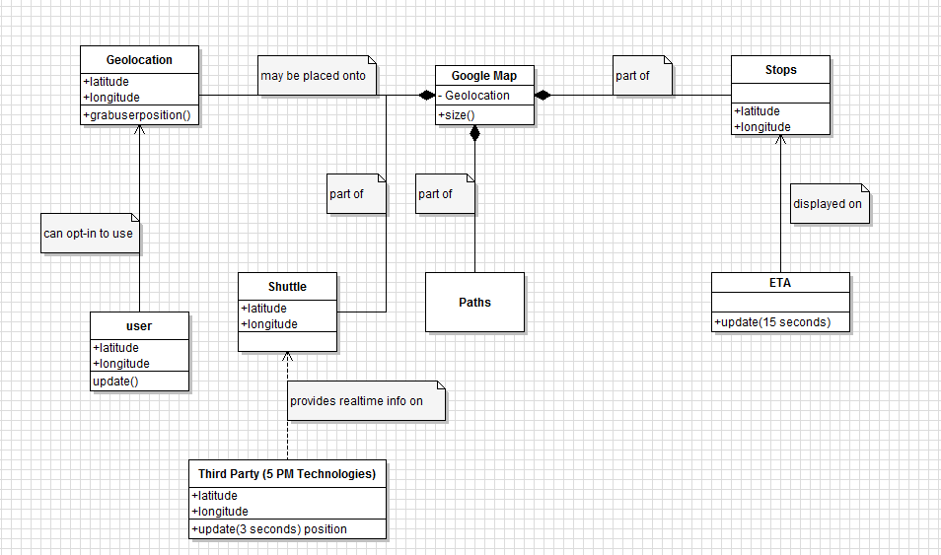

* 1. *System Context*

***Use Case Model***

**Map and visual representation of the shuttle**

**ETA Functionality**

**Route and stops of the Shuttle**

**Students/Faculty (can view the ETA, Map, Route, and Stops each time they go on the website)**

* 1. *Architecture Design*

***Modules/Components***

**Module: www.wsushuttle.com**

*User goes on*

*to the website*

**Component: Map**

*User views the*

*Map*

**Module: Map**

**Components:**

* **Route**
* **Stops**
* **Shuttle Visual Representation**
* **ETA Functionality**
  1. *System Design*

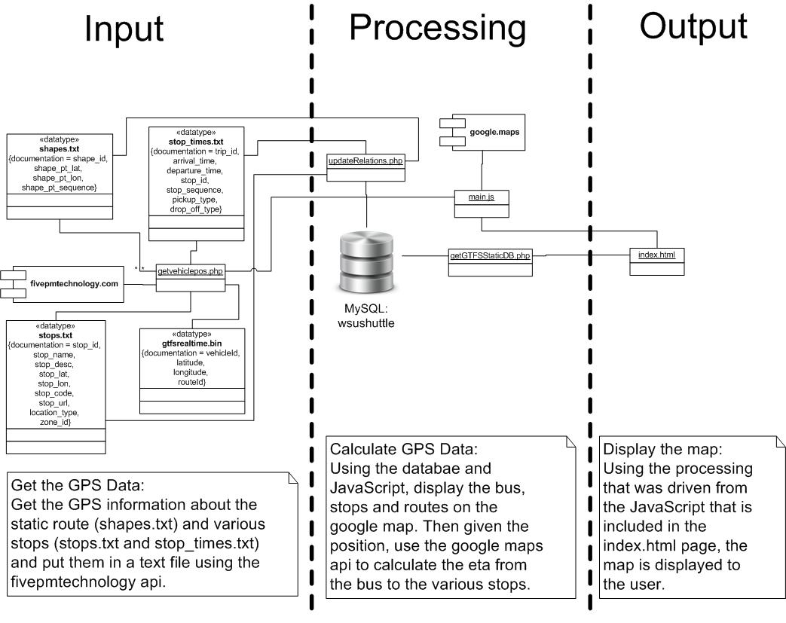

* 1. *Other Issues*

During the non-operation times of the shuttle, the visual representation of the shuttle on the map is not at its proper location. The user has to zoom out several times to be able to see the shuttle. The visual representation would not be on the route and would be out of the scope of the route.

1. Testing Plan
   1. *Approach for Testing*

The testing approach that we have used for integration testing was bottom-up testing. We decided to code and test once we had our very first module developed before having the latter modules developed. This approach was methodical, helped us pin-point problems easily, and gave us a basic idea of how the program will work for us for the other modules. It also offered us the advantage of code re-usability. We were able to take advantage of that as some of the code that was used in earlier modules was also used in latter modules and we did not have to write the code from scratch. We used Performance Testing technique for Non-Functional testing and Usability Testing for the System Testing.

* 1. *Functional Testing*

We examined the functionality of the application or what our software does by building test cases around the specifications and requirements.

***Test Case I:***

Test All Possible Outputs: Test the accuracy of the location of the shuttle on the map and the effectiveness of the ETA functionality.

***Test Case II:***

Test valid and invalid inputs: The GPS input in the data such as the GTFS files. There are no user inputs.

***Test Case III:***

Test around Boundaries: The location of the shuttle from each stop.

***Test Case IV:***

Test extreme values: Testing the ETA of a stop from another stop that is very far away.

* 1. *Non-Functional Testing*

The non-functional testing technique that we used for the project was Performance Testing to determine how our system works in terms of responsiveness and stability under a particular situation or condition. Following are the types of test that were conducted:

* Load Testing: Have multiple users go on to the website and test the performance of the website with multiple users using the system.
* Stress Testing: Test how the system recovers from a fail or error gracefully.
* Soak Testing: Have multiple users use the system for a long period of time.
* Configuration Testing: Test the system under development on machines which have various combinations of hardware and software.
* Isolation Testing: Test the system breaking down into various modules so that defects can be spotted easily in isolation.
  1. *Integration Testing*

We used the bottom-up testing technique for the integration testing to test and expose faults in the interaction between integrated units. In the bottom-up approach, we tested our bottom level units (such as route and stops) first and then our upper-level units (such as the ETA) step by step.

* 1. *System Testing*

For the system testing phase we went with the Usability Testing to mainly focus on the user’s ease to use the application, flexibility in handling controls, and ability of the system to meet its objectives. We tested the implementation of the website and the mobile application and analyzed how user-friendly the two applications are for a user.

* 1. *User Acceptance Testing*

We selected some of our classmates for the user-acceptance testing as our testing users to make sure our system can handle required tasks in real-world scenarios, according to the specifications. Following were steps involved in the user-acceptance testing phase:

* Designing Test Cases: Test cases were designed to cover all the functional scenarios of the software in real-world usage.
* Selection: The selection of the testing team was comprised of real world end users.
* Execution: The testing team executed the designed test cases. All bugs were written and kept track of.
* Bug-fixing: Responded to the bugs that were recorded after the execution of the test cases by the testing team. The group made final adjustments and changes to the code to make the system bug-free.
* Sign-off: When all the bugs were fixed, the testing team indicated acceptance of the software application which approved that the system covered all the requirements.
  1. *Schedule*

|  |  |
| --- | --- |
| **Order No.** | **Type of Testing** |
| **1** | **Functional Testing**: Defined test cases and tested the functionality of the system according to how the system responded to the test cases. |
| **2** | **Non-Functional Testing**: Executed Performance Testing; Performed Load Testing, Stress Testing, Spike Testing, Soak Testing, Configuration Testing, Isolation Testing |
| **3** | **Integration Testing:** Performed bottom-up testing technique to test the bottom level domains or first modules first and then went up in the level step by step. |
| **4** | **System Testing:** Executed Usability Testing to check the ease of implementation of the system for the users. |
| **5** | **User Acceptance Testing:** Performed the following steps----Designing Test Cases, Selection of team for testing, Execution of the test cases, Fixing the bugs, and completion of fixing the bugs and getting the approval of the testing team for the system. |